**Advanced Enterprise Java**

**Project-2**

Submission by Swapnil Patel (1966690)

https://github.com/swap1210/ Adv-java-assignment2/

Table of Contents

How to Execute: 3

isPalindrome: 3

Output: 3

goCaesar: 3

Output: 3

Match-a-pattern 3

Output: 4

# How to Execute:

To execute just run the Driver.java file inside src folder.

> javac Driver.java && java Driver

# isPalindrome:

To use Palindrone program just press 1 in choice menu

Followed by your String to be tested for Palindrone

Press 1 again if you want to test other string

## Output:

# goCaesar:

Press 2 to start Caesar Cipher class:

Give a filename or string to be encrypted.

If you give a filename, then content of the file will be picked for encryption

Then give the shift key value for encryption

## Output:

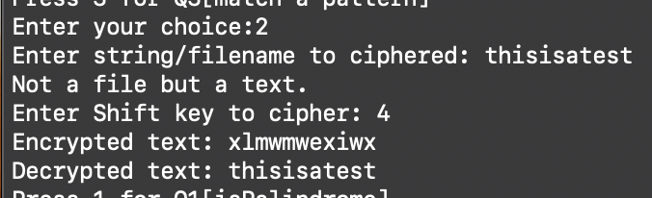

# Match-a-pattern

Press 3 to start match-a-pattern program

Enter the filename to be scanned

Enter the pattern to be matched

## Output:

